Name: _______________________ Date: ____________ Period: _______

Solve each of the inequalities below.

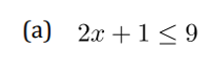



Solve each of the inequalities below.



